**Understanding the Problem**



In order to run the program well, the program has to fundamentally pass three steps. The first step is read the user’s id and password and detect the error of the input. Then, the second step is offering main choices and function the choices which the user wants. Finally, the third step is handling the information as the user chose. For instance, if the user wants to display the information on the screen, the program has to print the information on the screen, and if the user wants to display the information to the file where the user had created or already exist, the program has to append the information to the file.

To be specific, the program has to read the user’s id and password and determine whether they are correct or not. If the id or the password is incorrect, the program has to notify the user that the id or the password is incorrect, and prompts the user to enter the id and the password again. After the user enters the id and the password, the program first indicates the information of the user and offers four choices, ‘sort spell books by number of pages’, ‘group spells by their effect’, ‘sort spell books by average success rate’, and ‘quit’.

If the user choose every choice except ‘quit’, the program has to offer two choices, print the information to the screen, and print the information to the file. If the user chooses print the information to the screen, the program will print the information to the screen, and if the user chooses print the information to the file, the program will ask the user to enter the file name which the user wants and then, the program will append the information to the file. If the file which the user entered exists, the information will be appended to the existing file.

**<Assumption>**

I assume that if the user enters the ID or PW wrong, the program will prompt the user to enter the ID and the PW again.

I assume that if the user do invalid choices, the program will prompt the user to enter a valid choice.

I assume that the program will infinitely iterate unless the user quits the program.

I assume that if the user’s status is a student, the program will hide the spells which effect is death or poison and never inform the user that the spells which effect is death or poison is hidden.

**Program Design**

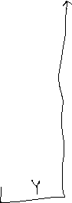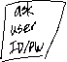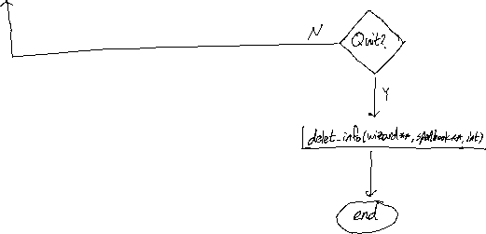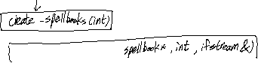

**<create_wizard(int)>**

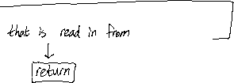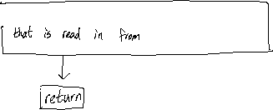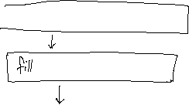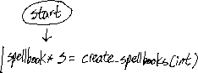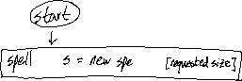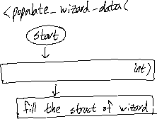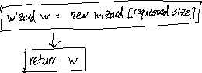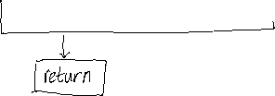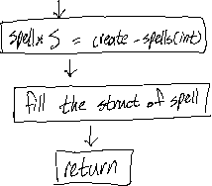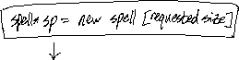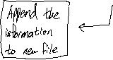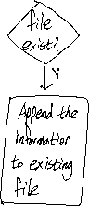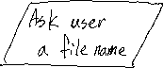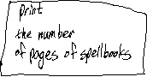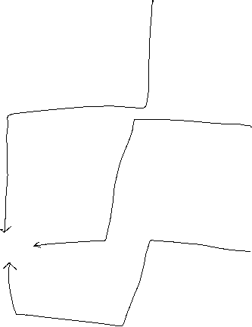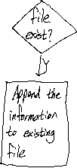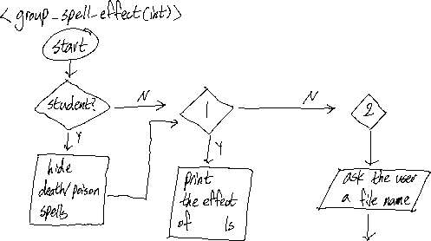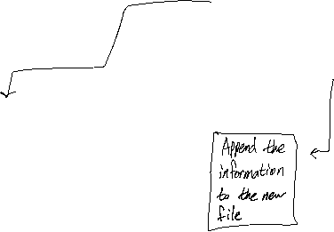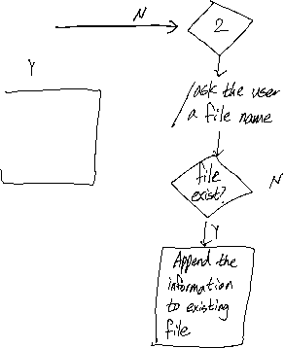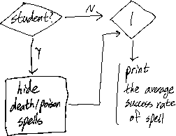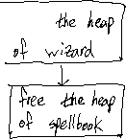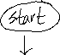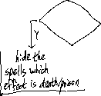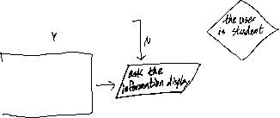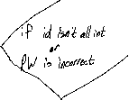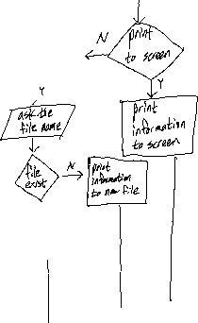

**Program Testing**

|  |  |  |
| --- | --- | --- |
| **Setting** | **Input** | **Expected Result** |
| <Step 1> | The user enters valid ID and PW. | Print out the user’s information and <Step 2> |
| <Step 1> | The user did not enter valid ID or PW. | Prompt the user to enter valid ID and PW. |
| <Step 2> | 1 | <Step 3> |
| <Step 3> | 4 | Prompt the user to enter 1 or 2. |
| <Step 3> | 1 | Print the information (sorted spell books by number of pages) to the screen. |
| <Step 3> | 2 | Ask the user a file name, and then append the information (sorted spell books by number of pages) to the file. |
| <Step 2> | 0 | Prompt the user to enter 1,2,3, or 4. |
| <Step 2> | 4 | End the program. |

<Step 1>

Please enter your id:

Please enter your password:

<Step 2>

Which option would you like to choose?

1. Sort spell books by number of pages
2. Group spells by their effect
3. Sort spell books by average success rate
4. Quit

Your Choice:

<Step 3>

How would you like the information displayed?

1. Print to screen (Press 1)
2. Print to file (Press 2)

Your Choice: